OUR SERVICES

SP offers different services at its petrol stations and at the customer’s premises.

[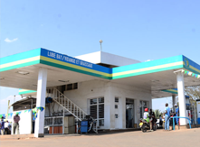](javascript:void%7b0%7d)

Rent facilities

SP petrol stations offer rent facilities including:

• ATM in partnership with banks   
• Carwash   
• Service Bay   
• Shop and Boutique   
• Food court   
• Tyre Center

[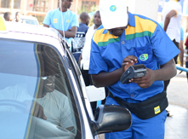](javascript:void%7b0%7d)

Electronic payment

SP accepts 3 types of electronic payment at all its petrol stations to enforce the cashless system across the country:

• VISA Card (in partnership with banks)   
• MTN Mobile Money (in partnership with MTN Rwandacell)  
• SP Fuel card

[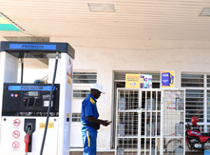](javascript:void%7b0%7d)

Other payment modalities

In addition to the Electronic payment, SP accepts the following payment modes:

• Bin Cards  
• Coupons  
• Cash

[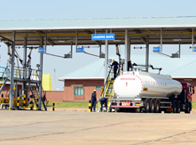](javascript:void%7b0%7d)

Other facilities

SP offers home deliveries service in bulk tanks and pump installation to the customer premises. This attractive service is offered mainly to construction companies, mining companies, energy and power plants, factories and other bulk consumers.